GESTURE TO SPEECH CONVERSION FOR DIFFERENTLY ABLED USING IMAGE PROCESSING
Sanjanaa Sridhar¹, Harshan S²
¹,²Student, Department of Electronics and Communication Engineering, SRM Kattankulathur, Chennai

---------------------------------------------------------------------***---------------------------------------------------------------------

Abstract: The objective of the project is to design a system that helps in recognizing the hand gestures, since it is difficult for special people to communicate their emotions, ideas and creativity to the people who don’t know sign language. The most important and feasible way for deaf and dumb people to communicate with other people in the real world is by using sign language. This gesture type communication technique utilizes a manual correlation structured by the individuals themselves. It is a well-constructed set of code gestures, each having specific meanings to it. It is considered as a tedious process for the mute people to communicate with people who lack skills in sign language. This causes a lot of hindrance in the social life and in turn, mental health. Having such a communication barrier in the society is the source of motivation to design and implement this system, where the user can merely perform the gesture in front of the camera after which the system compares this particular input gesture to the ones that are stored in the database. This was done by employing image processing with a deep learning model built in python. After comparing the input with the database gestures, it produces the accurate English translation to the user in the form of audio output.
Key Words: Image Processing, Hand gesture, Convolution Neural Network, Gesture Recognition, Model building and Prediction, Data processing, Jupyter Notebook, Deep Learning.

1.INTRODUCTION

The proposed idea has been developed to overcome and eliminate the problems faced by the differently abled. With the proliferation of computer vision and intelligent terminals, there is a growing demand for intelligent and personalized human-computer interaction (HCI). Due to the disadvantage that the traditional HCI devices having multiple inputs have poor interaction efficiency, voice, face, fingerprint or gesture is the most common interaction method for humans. Gesture and sign language has become a critical research direction in the field of intelligent HCI. The target image of the hand region is segmented by background subtraction, and tracked hand gestures using prior knowledge of the colour space of the hand skin. Following the principle of image processing, the image was extracted and recognized. The procedural block diagram for hand gesture recognition system consists of various stages such as image acquisition, hand position detection, cropping hand portion, pre-processing, feature extraction, classification, gesture to speech conversion. The user shows the signs and gestures in front of the web camera which captures the signs in intervals of 5 seconds. The image which is captured is processed and the region of interest, i.e., the hand portion is cropped, extracting it from the unwanted background. The cropped image is in the form of a colored picture. This is converted to a grayscale image and then converted to 1’s and 0’s using binarization. These collected values are fed to the machine learning model to predict the meaning of the accurate gesture. The final step is obtaining the translated English audio which is pronounced out, and hence makes the communication much easier. The objective of the project is to show the particularly template-based model, such as CNN and RNN. Feature extraction is one of the pre-treatment steps, aimed at reducing the dimension of data and extracting the relevant information. On the other hand, image pre-processing such as sharpening, slant correction or elastic distortion is necessary because the blurred images will affect the accuracy of feature extraction. This project will introduce image processing, feature selection and the relevant classification techniques that contribute to hand gesture recognition. Also, it provides an in-depth and detailed overview of the CNN model.

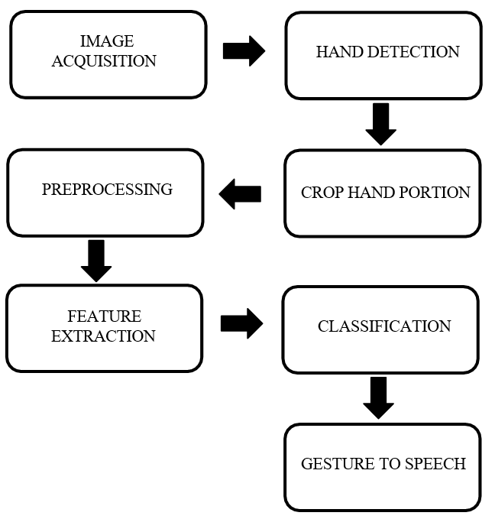
Figure 1- Block diagram

By the acquisition method, gesture recognition is incorporated mainly either by external sensors or computer vision. The external sensor-based technique obtains gesture characteristics by processing the gesture information collected by wearable devices like data gloves, electromyographic sensors, and linear bending sensors. But this technique incurs a high device cost, and lacks diverse sensing functions. The main drawback of the electronic speaking glove is that it is not an all-weather equipment. We can use waterproof gloves which are made up of Waterproof electronic materials but they are expensive. Also, the gloves are to be carried along with the user which is not so user friendly. So, to overcome these obstacles a program for gesture to speech conversion using image processing with open CV is developed. For image processing a CNN algorithm is deployed. CNN algorithm is used because of its high accuracy & efficiency. The CNN algorithms are currently the best algorithms for automated image processing. We can even convert this program into an application which can be used in Mobile phones, Tablets etc. Which makes this even more user friendly as nowadays everyone carry either a phone or tablet along with them everywhere. As a result, the computer vision-based technique has attracted more attention from researchers.

2. METHODOLOGY

The coding is done by utilizing Python language and the software used is JUPYTER NOTEBOOK and the libraries used here are NUMPY, TENSORFLOW, KERAS, OS, OPENCV, GOOGLE TEXT TO SPEECH.

2.1 IMAGE PROCESSING

Image processing is a technique to perform operations on an image, in order to obtain an enhanced image or to extract useful information from it. It is a type of signal processing in which the image is given as an input and output may be obtained as an image or characteristics/features associated with that image. It structures core research area within engineering and computer science disciplines. Based on the methods used for image processing they can be classified into two namely, analogue and digital image processing. Analogue image processing is used for hard copies like printouts and photographs. Whereas, Digital image processing helps in manipulation of digital images by using computers. All types of data have to undergo these three general phases while using digital techniques namely pre-processing, enhancement, and display, information extraction.
Sampling and Quantization-An image function f (x, y) must be digitized both spatially and in amplitude, in order to be appropriate for digital processing. The analogue video signal is often quantized and sampled using a frame grabber or digitizer. Continuous data must be converted into digital form in order to create an image which is digital. There are two steps in which it is done: Sampling and Quantization. The sampling rate determines the spatial resolution of the digitized image, while the quantization level determines the number of gray levels in the digitized image. In image processing the magnitude of the sampled image is expressed as a digital value. Quantization can be termed as the transition between continuous values of the image function and its digital equivalent. Quantization gives a grayscale image as output which has different levels of resolution with different values. When the quantized level is 256 it produces a clear gray scale image with more shades of Gray and it turns to complete black and white with the decrement of the quantized level.
Filtering- Filters are mainly used in image processing to repress either the high frequencies in the image, i.e., smoothening of the image, or the low frequencies, i.e., enhancing or detecting edges in the image. Image is filtered either in the frequency or the spatial domain. A Mask acts as a filter. The perception of masking is also known as spatial filtering. Filters are used for blurring and noise reduction. Blurring is employed in pre-processing steps, like removal of small details from an image preliminary to large object extraction.
Convolution- Convolution is an operation in which two arrays are merged by multiplying them, the arrays which are being merged could be of different sizes, the only condition is that the dimensions should be the identical for both arrays. Convolution is the process of convolving a mask over an image. Gray Level images are generally used as an input array as far as image processing is considered. Mask is a signal also known as a filter. It is represented in a two-dimensional matrix. The mask is generally of the order of 1x1, 3x3, 5x5 and 7x7. A mask should always be in odd numbers, because otherwise one cannot find the middle of the mask. In order to execute convolution on an image, following steps must be implemented
(i)Flip the mask (horizontally and vertically) only once
(ii)Slide the mask onto the image.
(iii)Multiply the corresponding elements and then add them
(iv)Repeat this procedure until all values of the image have been calculated.
The approach of the problem using Convolutional Neural Networks in order to get a higher accuracy. Several researches have been undertaken to improve the accuracy of sign language prediction. Firstly, a model has to be defined that will be trained with the dataset which contains over 100 train images for each sign and will be validated using the test dataset. Prior to training the sequential model with the train images, the images were required to apply some pre-processing techniques to data in order to make it more fitting for the model.

2.2 IMPLEMENTATION

Image/Data pre-processing-The aim of pre-processing is to improve the quality of the image so that it can be analyzed in a better way. Pre-processing suppresses undesired distortions and enhances some features which are necessary for the particular application. In this work of Gesture to speech conversion only the gesture is required from the image anything other than the gesture must be removed for better results and efficiency. For example, fully connected layers in convolutional neural networks require that all images are the same sized arrays. Image pre-processing decreases model training time and increases model inference speed.
RGB to Grayscale-One of the main reasons why we convert RGB images to grayscale is because the RGB image contains a lot of data which may not be required for processing, converting a RGB image to Grayscale discards a lot of information which is not required for processing. Also, some of the algorithms can only be implemented on 2D images rather than 3D images. The methodology used in this research paper for the conversion of RGB to grayscale of the selected ROI is by using the function cv2.cvtcolor. roi=cv2.cvtcolor(roi, cv2.color_BGR2Gray) is the code used here to convert from RGB to grayscale.
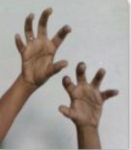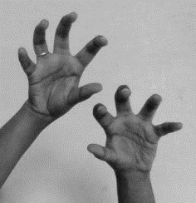
Figure 2- RGB to Grayscale Coversion

Binarize- The Grayscale image thus produced is converted to a binary image. While the grayscale image had 0 to 255 levels, the binary image has only two; 0 and 1. Binarization is the method of converting any Gray – scale image (multi tone image) into black – white image (two tone image). Binarization is necessary because Auto encoders are not able to recognize the images because of the noise in the images, otherwise referred to as “image processing.” For avoiding the background noise generated in images we will use a Binarization technique commonly employed with artificial intelligence.
Grayscale filtering- The main aim here is to attain the most accurate results by reducing the noise as much as possible. In this a threshold is used to filter out noise in gray scale images. The threshold used in this system is 120, it was giving better results.
Noise removal and smoothing- Noise in the image needs to be removed, because it will affect the results. If features extracted from a noisy image are used and classified, it will mislead and will result in bad classification and results. In order to remove noise from the image a 3x3 median filter is used. What it does is that it will create a small matrix of dimensions 3x3 and this matrix will move on the image pixel by pixel. This will calculate the median of its neighborhood pixels. It will also make edges clear. The result of this filter is evident in the output.
Feature Extraction- Feature Extraction is a unique form of dimensionality degradation. When an input data to an algorithm is too large to be processed and suspected to be infamously redundant then the input data will be modified into a reduced representation set of features. Conversion of input data into a collection of features is termed as Feature Extraction.
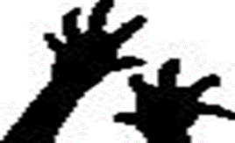
Figure 3- Extracted image

Model Building and Prediction- The CNN model (Convolution Neural Network) for identifying the hand gestures is constructed using the library of python backend. The most popular type of model used is sequential. It consists of a linear stack of layers. Defining a model basically means adding different layers to the stack.
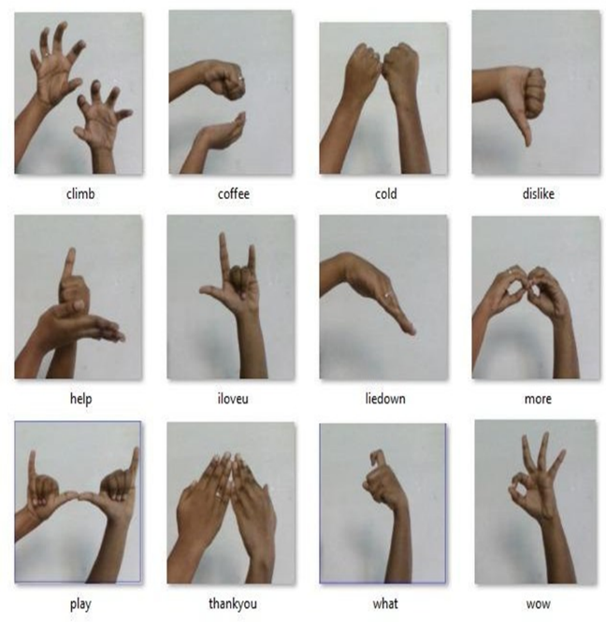
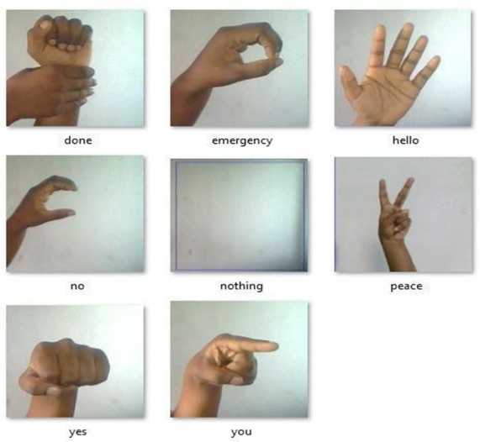
Figure 4- Collected images

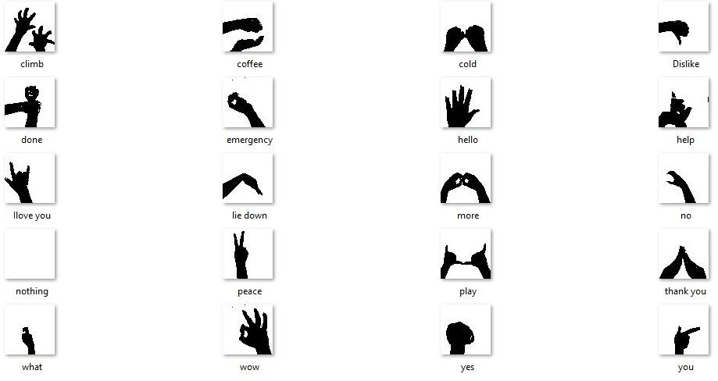
Figure 5- Pre-Processed images

2.3 CODE AND ALGORITHM

- Import libraries.
- Check whether the specified path exists or not using os.pathexists()
- Create the required directories using os.make dirs.
- Train the model by image capturing through your systems webcam.
- Simulate the mirror image for the captured ones.
- Get the count of existing images in the directory.
- Print the count in each set on the screen.
- Give co-ordinates for region of interest (ROI).
- Draw the ROI on screen using CV2. Rectangle syntax.
- Now only the ROI is extracted from the image.
- Image processing is done after the ROI is extracted.
- Now, dataset needs to be trained, so, import Keras and packages.
- Build the Convolution Neural Network.
- Add required layers and pooling.
- Flatten the layers and add a fully connected layer.
- Compile the CNN.
- Prepare the train/ test data and train the model.
- Make a loss and accuracy plot.
- Save the model and perform prediction.
- Load the model and weights into the new model.
- Sort the results based on top prediction.
- Display the predictions.
- Captured gesture is recognized and converted into speech audio.
The GitHub link for the code and layers used is https://github.com/harshan7090/Gesture-to-Speech-Conversion-using-image-processing

2.4 OUTPUT

The following images show the correctly predicted sign. The accuracy of prediction at the 50th epoch is 0.9593. This shows the Convolution Neural Network gives more accuracy than any other algorithm.
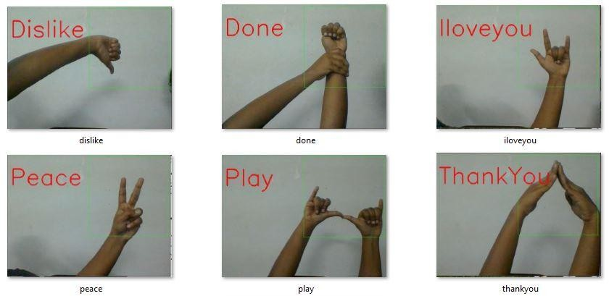
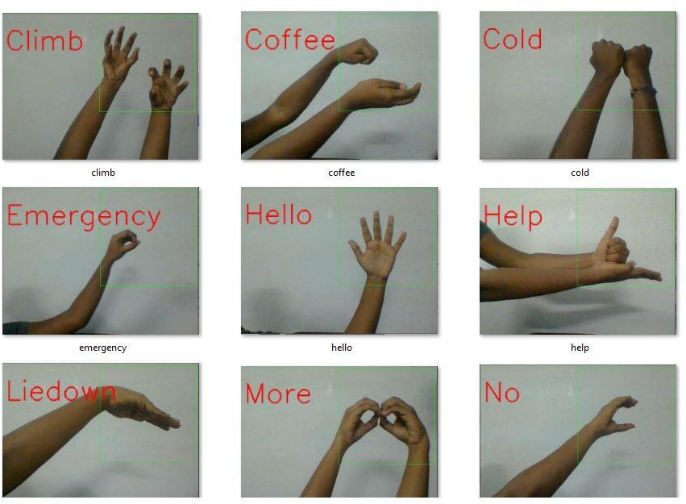

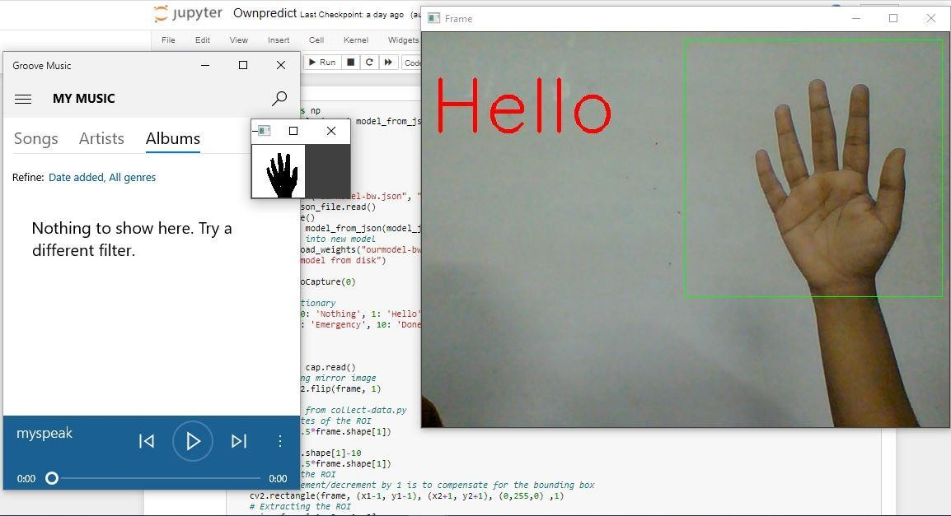

Figure 6- Output images

3. CONCLUSIONS

A system to recognize the sign language and convert it to speech is developed using deep learning techniques. Image processing algorithms are used to extract the features of hand gesture and then the sign captured at that instant is classified using the Convolutional Neural Network algorithm. The sign recognized by the CNN model is displayed as text. gTTS api converts the text to voice. Thus, the system behaves as a voice provider for the people with hearing and speech impairment. The system efficiency can be improved by using a greater number of training images to train the classifier. The extraction of features can be further improved by using clustering techniques. Using CNNs like Google Net, AlexNet etc., and increasing the number of hidden layers can improve the accuracy of the system

4. REFERENCES

- K.M.M. Rao "OVERVIEW OF IMAGE PROCESSING" Readings in Image Processing Fundamentals of Digital Image Processing - Anil K. Jain, Prentice-Hall, 1989.
- Gaurav Kumar, Pradeep Kumar Bhatia"A Detailed Review of Feature Extraction in Image Processing Systems" 2014 Fourth International Conference on Advanced Computing & Communication Technologies.
- Halima, N.B., 2016, “A robust method for hand gesture recognition using support vector machine”, International Journal of Multimedia and Ubiquitous Engineering, 11(11): 365-374.
- Nguyen-Dinh, L.V., Calatroni, A., Tröster, G., 2016, “Supporting one-time point annotations for gesture recognition”, IEEE Transactions on Pattern Analysis and Machine Intelligence, 39(11): 2270-2283.
- Sudha, M.R., Sriraghav, K., Jacob, S.G., Manisha, S., 2017,” Approaches and applications of virtual reality and gesture recognition”, International Journal of Ambient Computing and Intelligence (IJACI), 8(4): 1-18.
- Gavrilova, M.L., Wang, Y., Ahmed, F., Paul, P.P., 2017, “Kinect sensor gesture and activity recognition: New applications for consumer cognitive systems”, IEEE Consumer Electronics Magazine, 7(1): 88-94.
- Moschetti, A., Fiorini, L., Esposito, D., Dario, P., Cavallo, F., 2017, “Toward an unsupervised approach for daily gesture recognition in assisted living applications”, IEEE Sensors Journal, 17(24): 8395-8403.
- Saad, M., Bleakley, C.J., Nigram, V., Kettle, P., 2018, “Ultrasonic hand gesture recognition for mobile devices”, Journal on Multimodal User Interfaces, 12(1): 31-39
- Roma, G., Xambó, A., Freeman, J., 2018, “User-independent accelerometer gesture recognition for participatory mobile music”, Journal of the Audio Engineering Society, 66(6): 430-438.
- Chaudhary, A., Raheja, J.L., 2018, “Light invariant real-time robust hand gesture recognition”, Optik, 159: 283-294.

